Krusty Krab

**Team members:** Icevar Naguleswaran, Kasim Tiba, Audrey Chang, Channy Nguyen

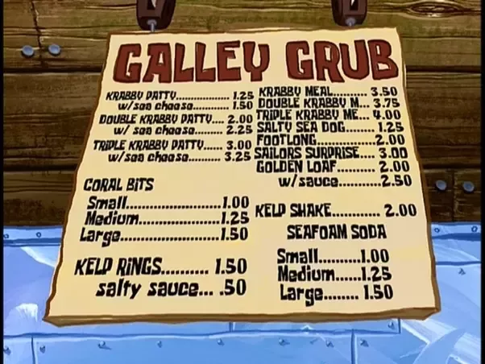

**OBJECTIVE**

Design a program that will provide customers of the Krusty Krab the ability to order from an online menu that would give them the ability to make orders into their shopping cart for delivery or in store pickups.

**CONTENT**

Our program will include a user-interface menu where the user can easily view the price of menu items, special deals, and special combos. Then, the user can place their order, get an online receipt for the order sent to a text file, and get an estimated time for when their order will be complete.

**PROCEDURE**

We will have two coders, one project manager who will help with debugging and keeping the group on track for completion, and one data manager who will create the database for the menu. We plan on creating a program that functions as a menu that customers can order off online and have it delivered to their doorstep.

**Required features:**

* User interface menu
* Make comments for special requests
* Shopping cart taken from user interface
* Print out final cost
* Pick up or delivery option

**Additional features:**

* Account login or one-time user option
* Print out receipt to a text file
* Coupons for next purchase
* Accept coupon codes for new deals
* Give a rating of the service (0 stars to 5 stars)

**FLOW DESIGN**

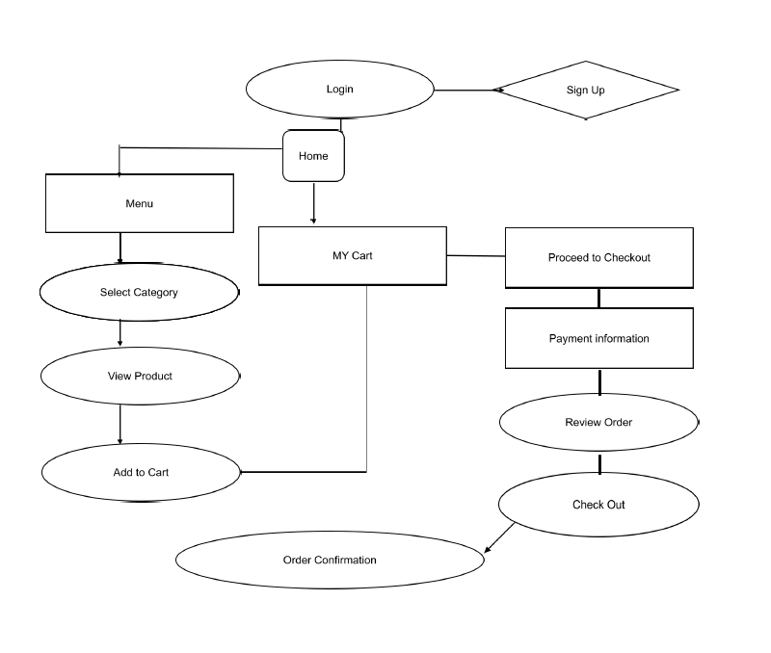

**IMPLEMENTATION**

Our program will require a menu that is accessed by user input for category, where they can view products as an array and then make a choice for what order they want, which will be stored in the user’s shopping cart. The record of their order can be printed out and will be implemented by our knowledge of accessing text files. The program will continue to run until the user indicates that they are completely done, likely done through the implementation of a while loop.

**TARGET USER**

Customers of the Krusty Krab that prefer an online interface that can ensure that their food is ready for pickup right when they arrive, or have food delivered to the comfort of their home through an easy to use online store. These benefits make better use of the customer’s time by not having to wait to make an order, or by being able to not leave your home to have a Krabby Patty delivered to you.

**POTENTIAL CHALLENGES**

A potential challenge in our program will be having different sections such as the signing up for an account aspect, or the menu, or the order confirmation all connecting cohesively if we split up these parts to separate team members. It will take special care for us to ensure that these parts all come together seamlessly, and effectively for the program to run correctly.

**Timeline:**

5/30: Menu completed, have food items listed out for the user’s view.

5/31: Shopping cart completed, have user’s orders be transferred to the shopping cart for purchase.

6/1: Added options for delivery, pickup, and special requests implemented into the user interface.

6/3: Receipt print out, have a text file printed out for the user’s convenience if they want record of their purchase.

6/5: Additional add-ons, anything that we would be nice to have should be implemented already.

6/5: Begin debugging process, ensure everything in the program is running together seamlessly.

6/12: Final check, make sure project works before presentation.